**Aim : Create a Poster to advertise an event**

**Steps to perform:-**

**1. Set Up Your Document**

* **Open Photoshop** and create a new document.
  + Go to **File > New**.
  + Choose the dimensions for your poster. Common sizes include:
    - **24 x 36 inches** (standard large poster)
    - **18 x 24 inches**
    - **11 x 17 inches** (smaller poster size)
  + Set the **Resolution** to 300 DPI (for high-quality printing).
  + Set the **Color Mode** to **RGB** for digital posters, or **CMYK** for printing.

**2. Create Guidelines**

* To help with alignment, use guides to ensure text and graphics are well-placed.
  + Go to **View > New Guide**.
  + Choose whether you want a vertical or horizontal guide, and set the position.
  + Repeat this step to create multiple guides if needed (e.g., for margins, centering, or columns).

**3. Set the Background**

* Select the **Background Layer** in the Layers panel.
* Choose a solid color, gradient, or image for your background.
  + To use a solid color: Select the **Paint Bucket Tool** (G), choose a color, and click on the canvas.
  + To use an image: Go to **File > Place Embedded**, then select your image file. Resize and position it to fit the canvas.

**4. Add Text**

* Select the **Type Tool (T)** from the toolbar.
* Click on the canvas and start typing your headline or other text. For posters, your headline should be bold and eye-catching.
* Use the **Character panel** (Window > Character) to adjust font, size, spacing, and alignment.
* For a poster, you might want to experiment with fonts that fit the theme. Use a large, bold font for the headline and a simpler font for additional text.

**5. Add Images/Graphics**

* If you have additional images or graphics to include, go to **File > Place Embedded** to add them to your poster.
* Resize and position the images using the **Transform Tool** (Ctrl+T or Cmd+T).
* Use the **Layer Mask** to hide parts of images or to blend them seamlessly into the background.

**6. Enhance with Effects**

* You can add visual interest to text and images using effects:
  + **Text Effects**: Double-click the text layer to open the **Layer Style** window, where you can add drop shadows, bevels, strokes, etc.
  + **Image Effects**: Apply filters (Filter > Filter Gallery) or adjustments (Image > Adjustments) to modify the look of your photos or graphics.

**7. Use Shapes and Icons (Optional)**

* You can use the **Shape Tool (U)** to add geometric elements like lines, circles, or rectangles.
* For social media or event posters, consider adding icons (e.g., social media logos, event date, location) by importing vector graphics or using the **Custom Shape Tool**.

**8. Adjust Layout and Composition**

* Ensure that the elements of your poster are balanced. Use the **Move Tool (V)** to reposition text and images.
* Use the **Align** options (in the top bar or in the **Move Tool** options) to center or distribute items evenly.
* You may want to experiment with **layer blending modes** to integrate images and text more naturally.

**9. Check for Readability and Contrast**

* Ensure that the text is legible from a distance. If needed, add a subtle drop shadow or outer glow to the text to make it stand out.
* Make sure the colors provide enough contrast, especially if the poster will be printed in black and white.

**10. Final Adjustments**

* Once your layout is set, adjust the overall image's brightness, contrast, and saturation if necessary by going to **Image > Adjustments** (Brightness/Contrast, Levels, Hue/Saturation).
* If you're working with a print poster, make sure the color profiles are set correctly (CMYK for print, RGB for web).

**OUTPUT :**

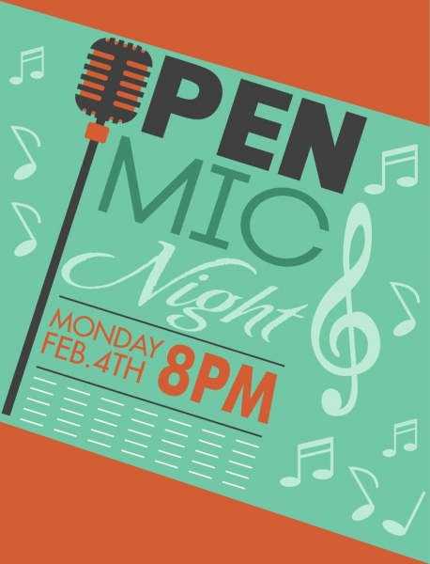

**Learning Outcomes :**

**1.We learn how to create a poster for an event.**

**2.Learn how to effectively format and style text.**

**3.Understand how to work with layers.**

**4.Understanding fundamental design principles.**

**MINOR PROJECT**

**REPORT**

**Desktop Publishing**

**Student Name: Alka Kumari UID: 23BCA10577**

**Branch:BCA Section: 9 “B”**

**Semester: 3rd**

**Subject Name: Desktop Publishing**

**Subject Code: 23CAP- 204**